NETWORK LOAD BALANCER (NLB)

NLB required TCP protocol

It follows only straightforward mapping

It will takes only one target group

NLB can handle huge traffic than ALB by TCP protocol

APPLICATION LOAD BALANCER (ALB)

ALB follows http protocol

It follows path based routing

It can also follows straightforward mapping

High availability across region

It is region specific

ELB supports high availability across AZ’s

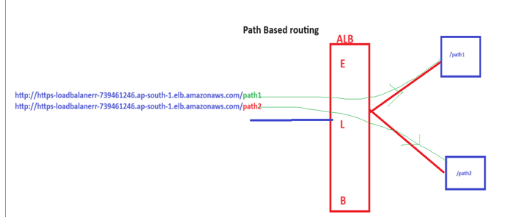

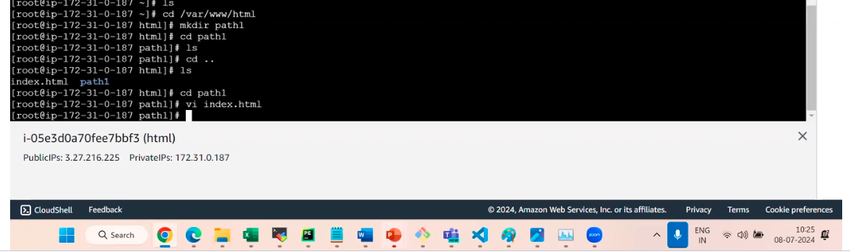

Cd /var/www/html (this is default path we are

creation Path1 and path2 in this only)

Mkdir path1 (creating file path1)

Cd path1 (moving to path1)

Vi index.html (to write)